**VIETNAM NATIONAL UNIVERSITY, HO CHI MINH CITY**

**UNIVERSITY OF INFORMATION TECHNOLOGY**

**FACULTY OF INFORMATION SYSTEMS**

**\*\*\*\*\*\***



**DECISION SUPPORT & BUSINESS INTELLIGENCE APPLICATIONS**

**Reporting project & SSIS project**

**Lecturer:**MSc. Nguyen Thi Kim Phung

**Class:** MSIS4263.P21.CTTT

**Student:** Ngo Manh Khuong - 21522241

Ho Chi Minh city, April 2025

**TABLE OF CONTENTS**

**1.** **Data preparation** 2

**2.** **Reporting project (MS Power BI)** 4

**a)** **List (Table)** 7

**b)** **Chart** 9

**c)** **Matrix** 10

**3.** **SSIS Project** 11

1. **Data preparation**

Kaggle dataset: <https://www.kaggle.com/datasets/benroshan/ecommerce-data>

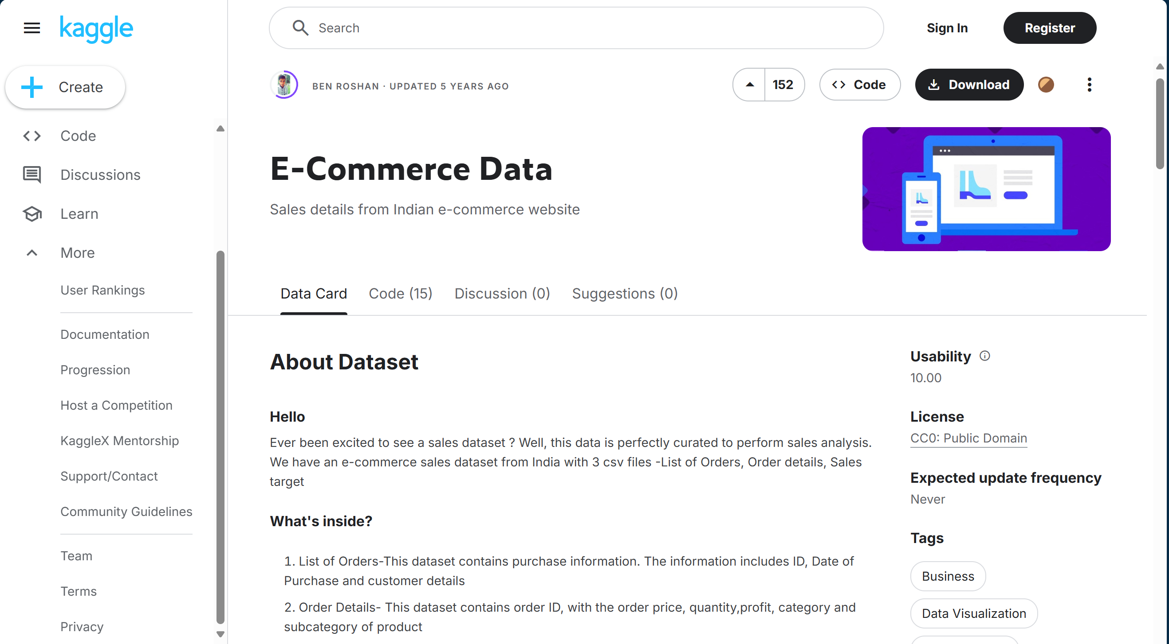

There are 2 datasets: List of orders, Order detail

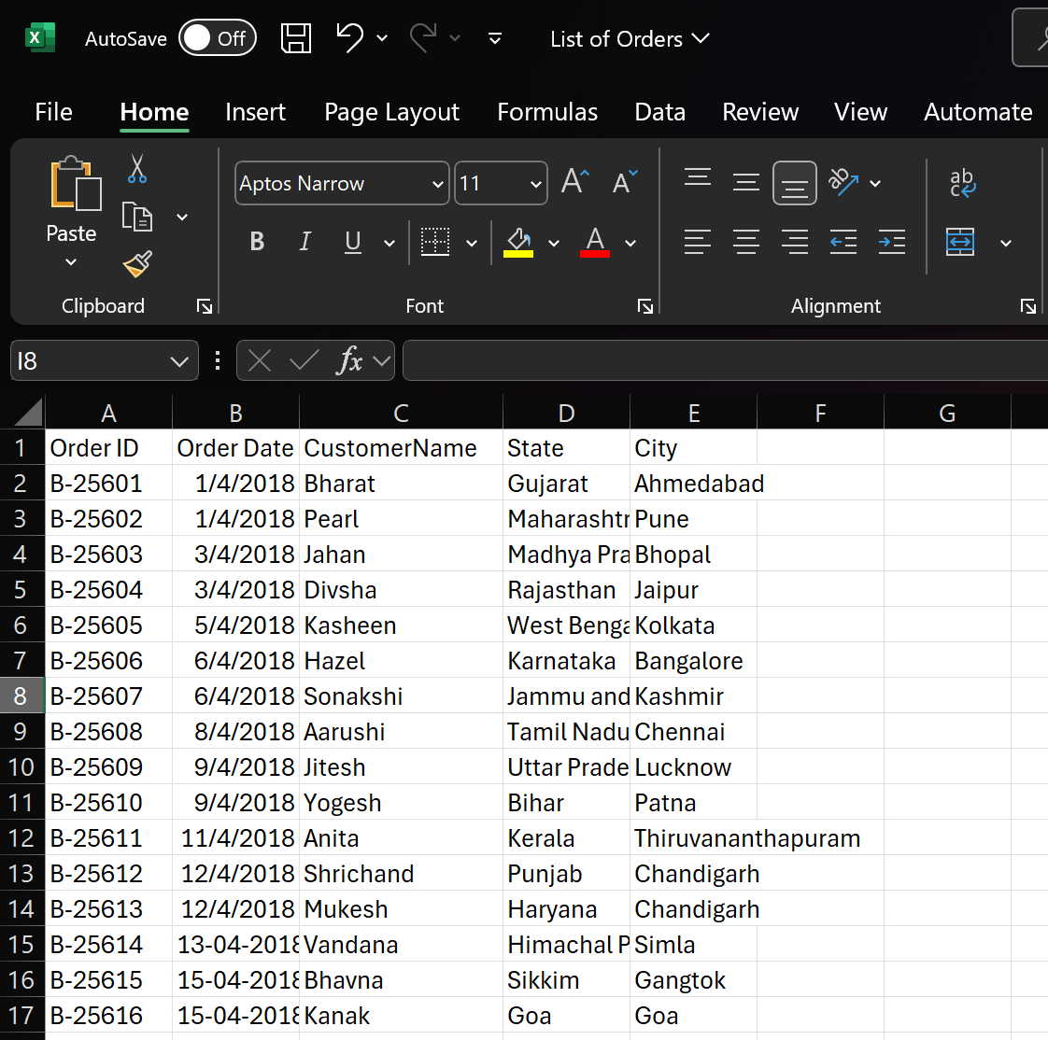

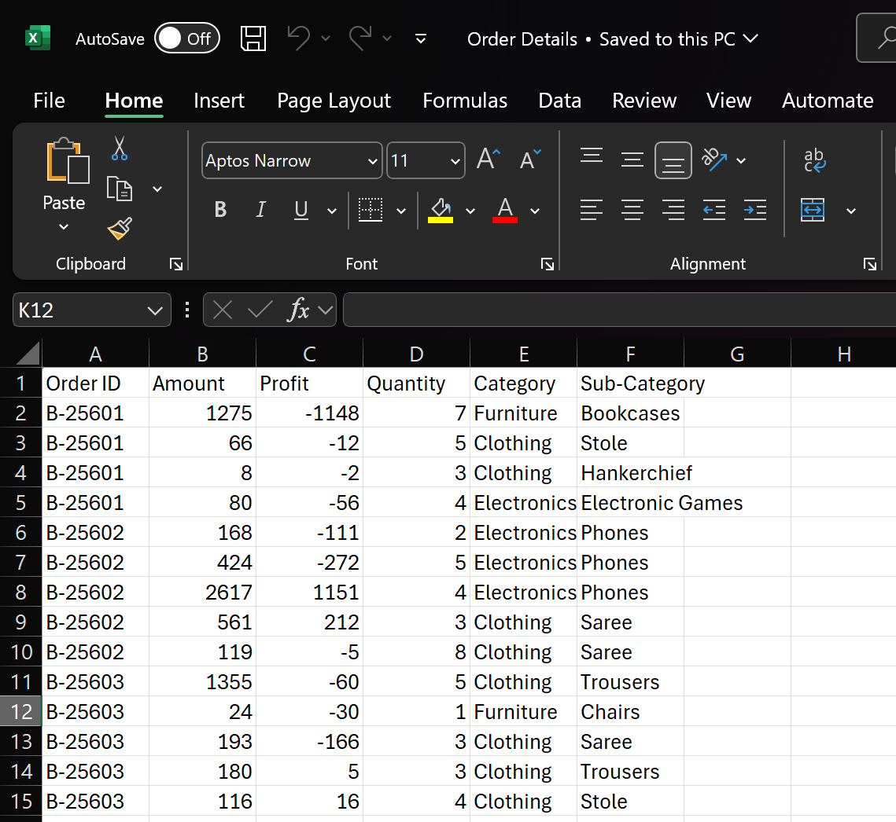

My dataset contains the following fields:

1. **Order ID** – A unique identifier for each order.
2. **Order Date** – The date when the order was placed.
3. **Customer Name** – The name of the customer who placed the order.
4. **State** – The state where the order was delivered.
5. **City** – The city where the order was delivered.
6. **Amount** – The total amount of the order.
7. **Profit** – The profit earned from the order.
8. **Quantity** – The number of items purchased in the order.
9. **Category** – The main category of the purchased product(s).
10. **Sub-Category** – A more specific classification of the purchased product(s).
11. **Reporting project (MS Power BI)**

Firstly, I choose Model view on the left side bar of PowerBI and click on “Get data”

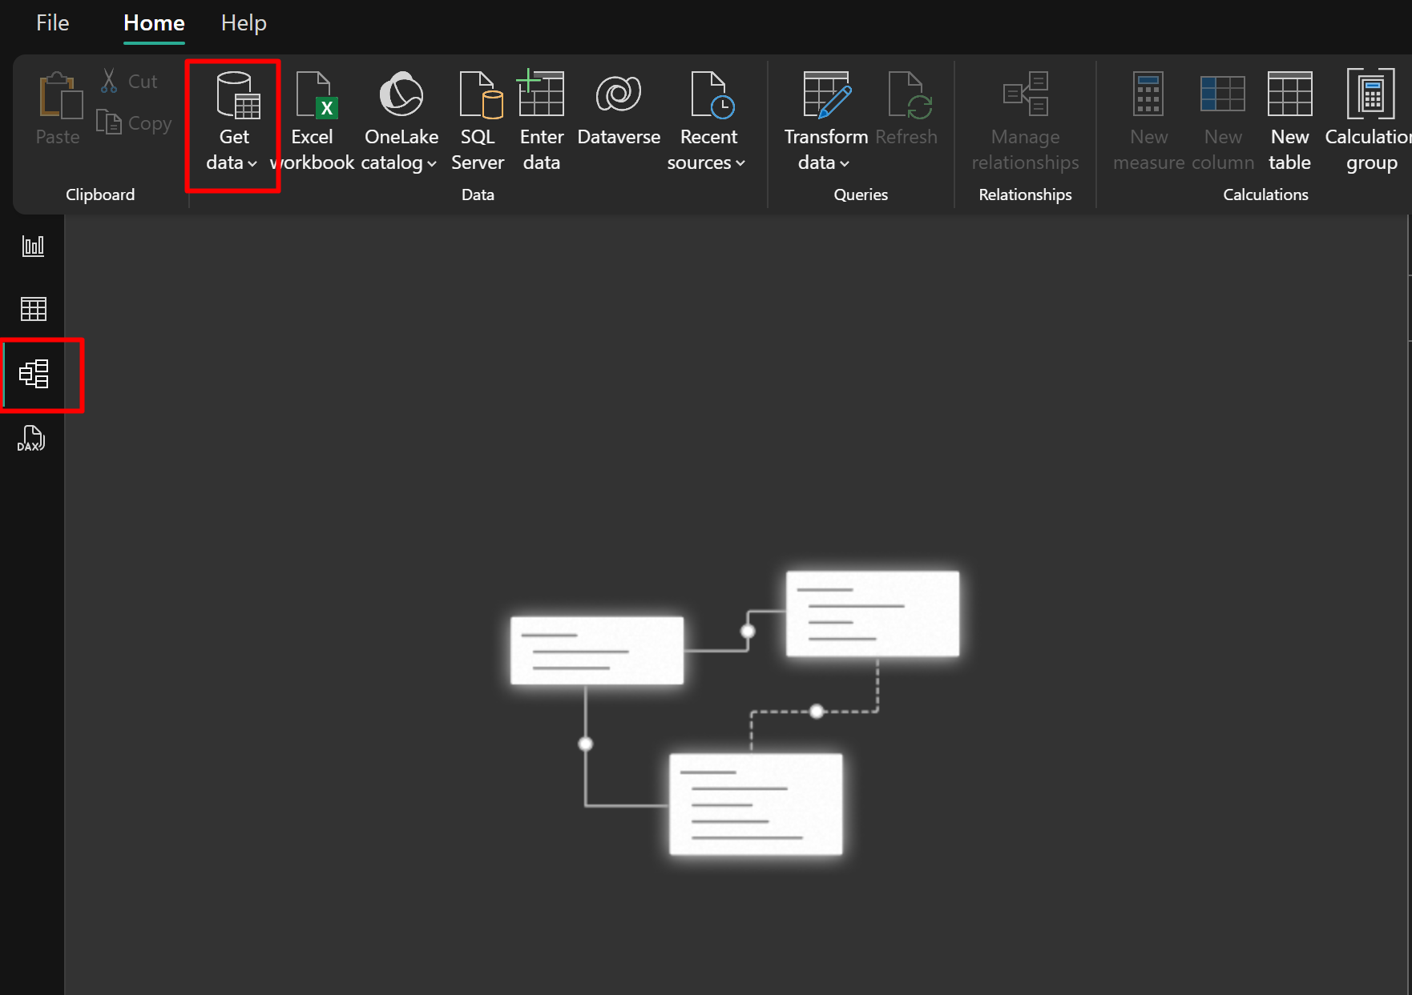

Choose data source from Excel workbook

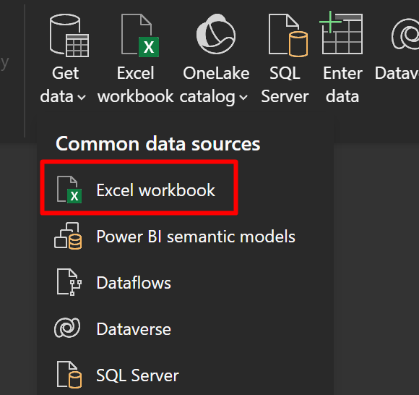

Next, I load data of each data source into PowerBI

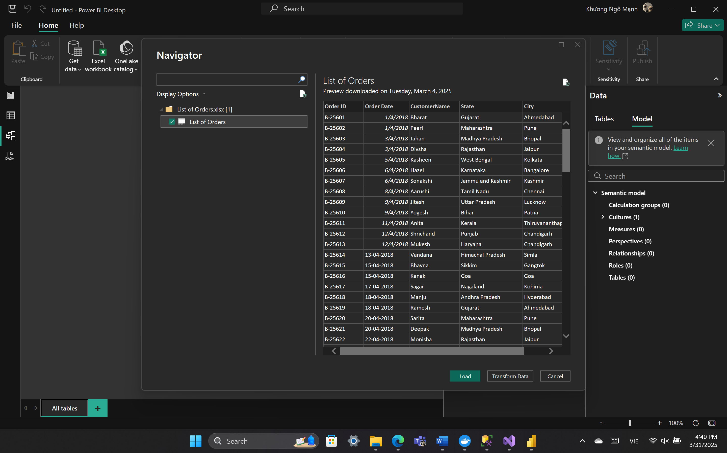

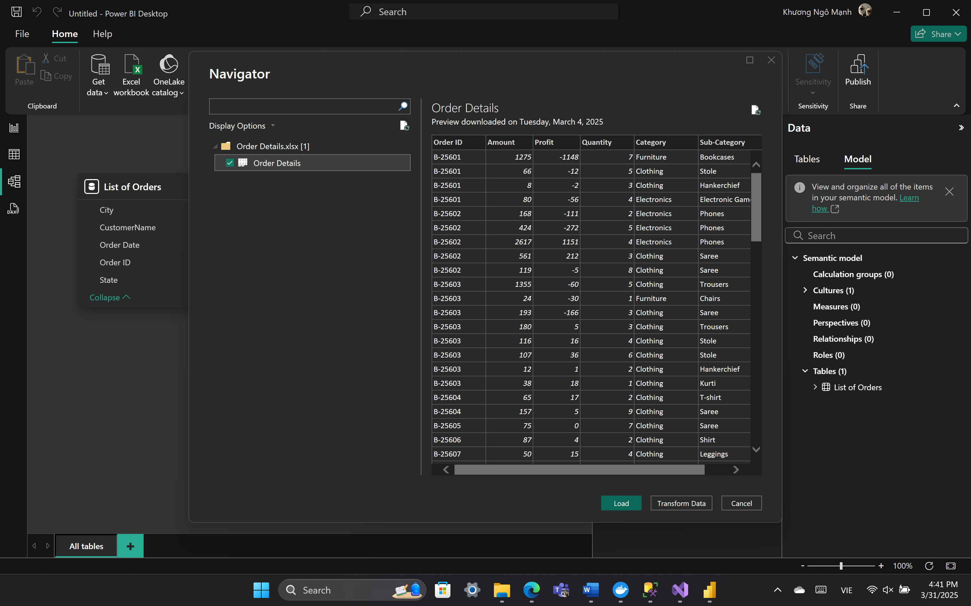

After loading data sources, two data sources are linked to each other by Order ID

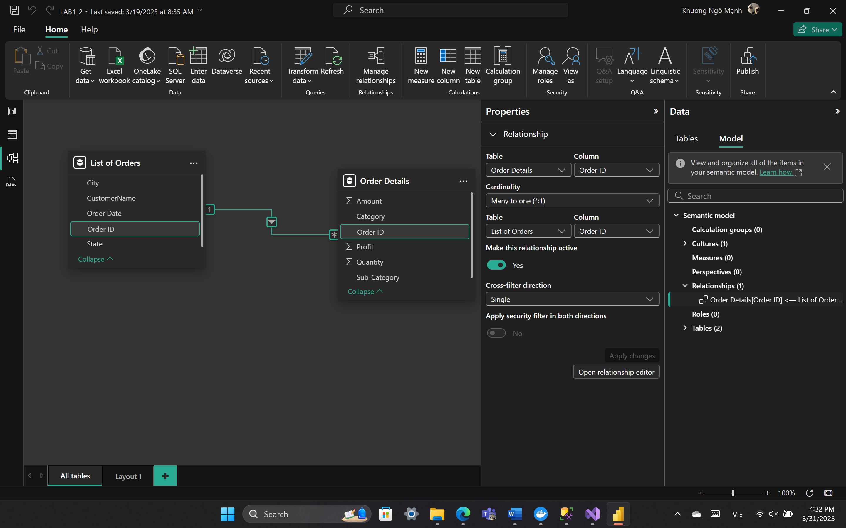

1. **List (Table)**

Get back to the “Report view” of PowerBI. In Visualization, select “Table”

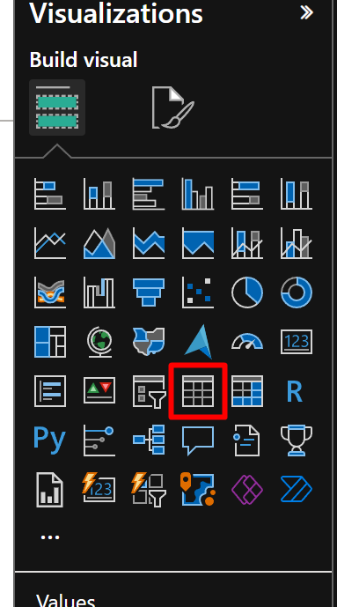

Select the fields: State, Sum of Amount for the column of table (list). So, I get the list of States and sum of amount of order in each state

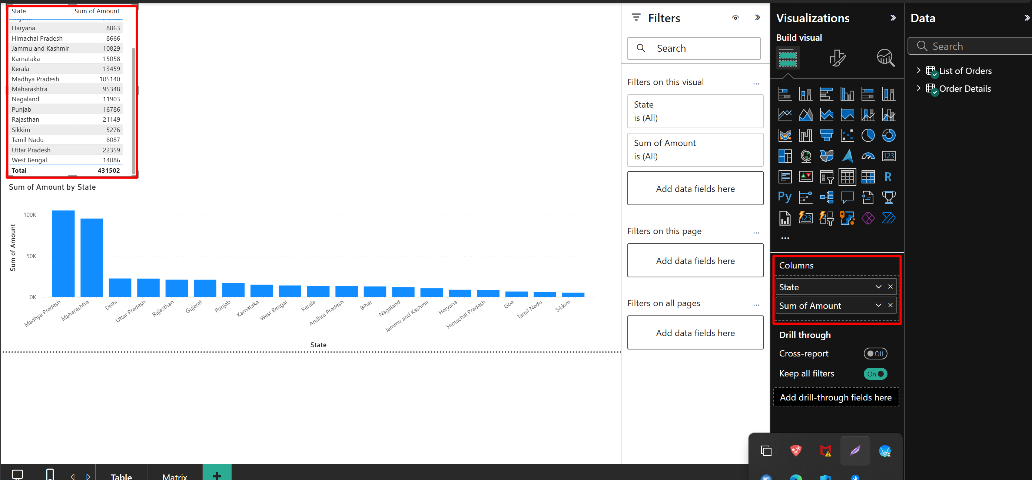

1. **Chart**

Select Clustered column chart in Visualization

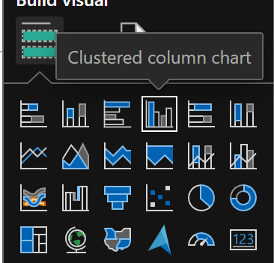

Choose State for X-axis, Sum of Amount for Y-axis.

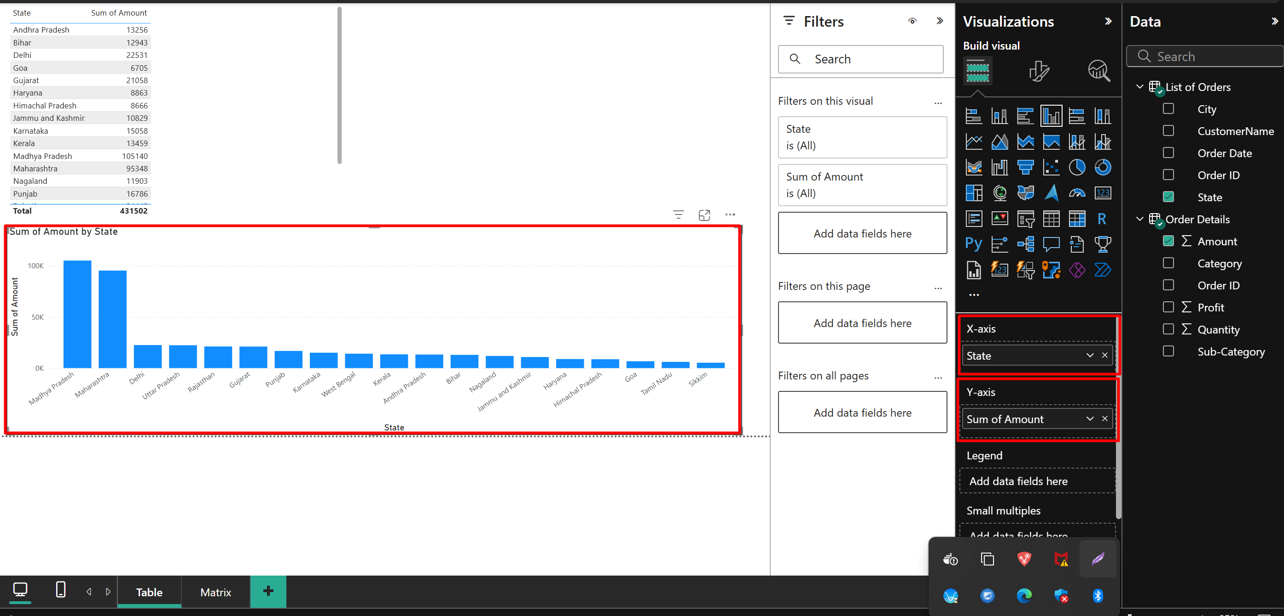

With Matrix, I do the same and select State for X-axis and Sum of Amount for Y-axis. I also select Category for Legend so I can filter the chart

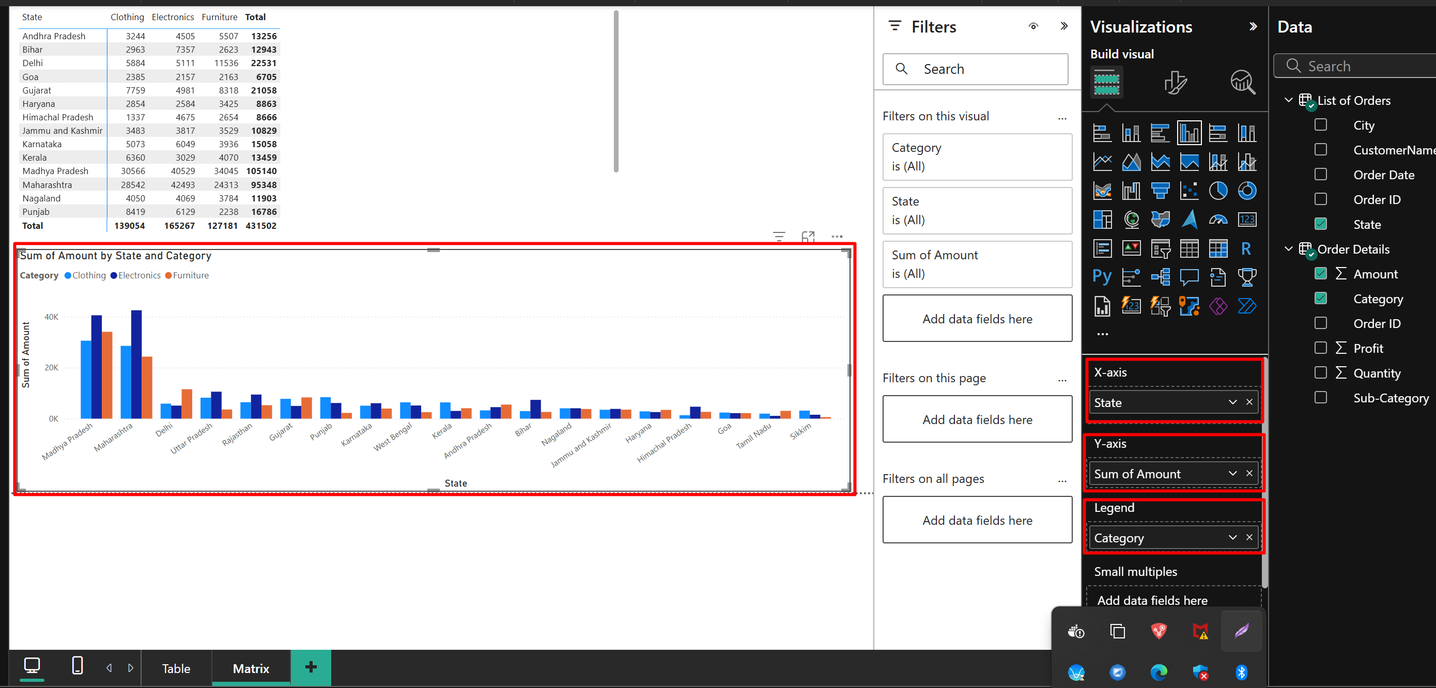

1. **Matrix**

Select Matrix in Visualization

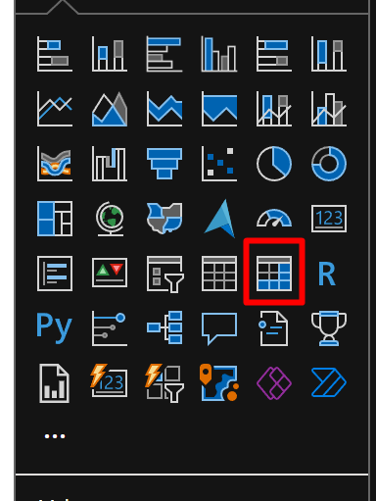

Select State for Row, Category for Columns, and Sum of amount for Values. So, I get the matrix of dataset which is grouped by Category and State

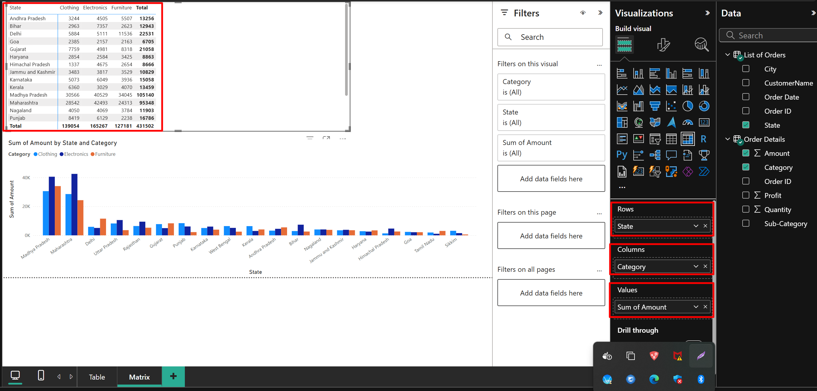

1. **SSIS Project**

In Data Flow, I set up the flow like image below. With data source is an excel file containing all information of orders.

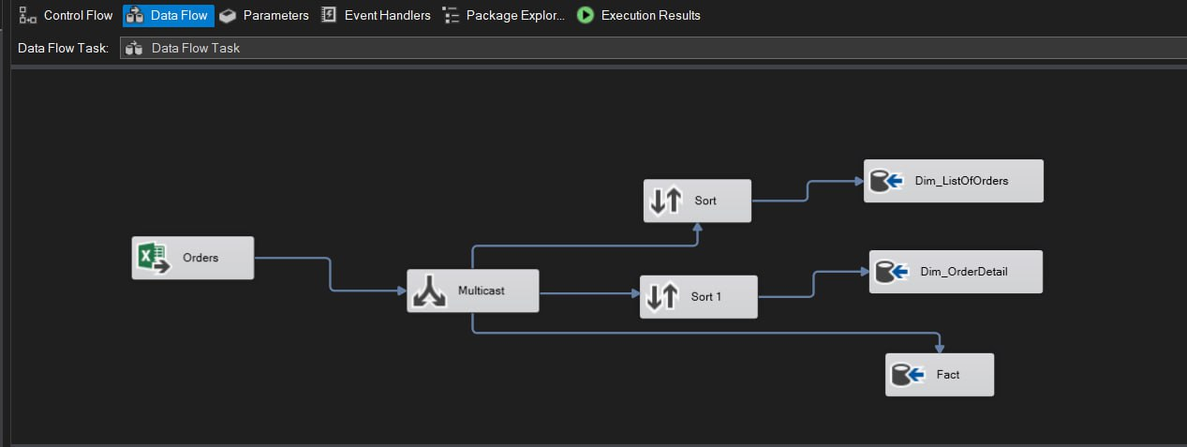

Below is my setting for data source

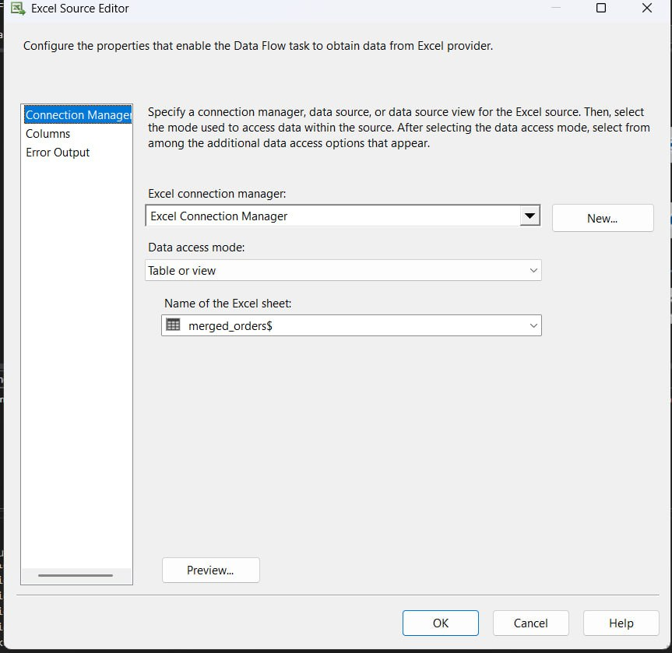

In Sort, I select Order ID.

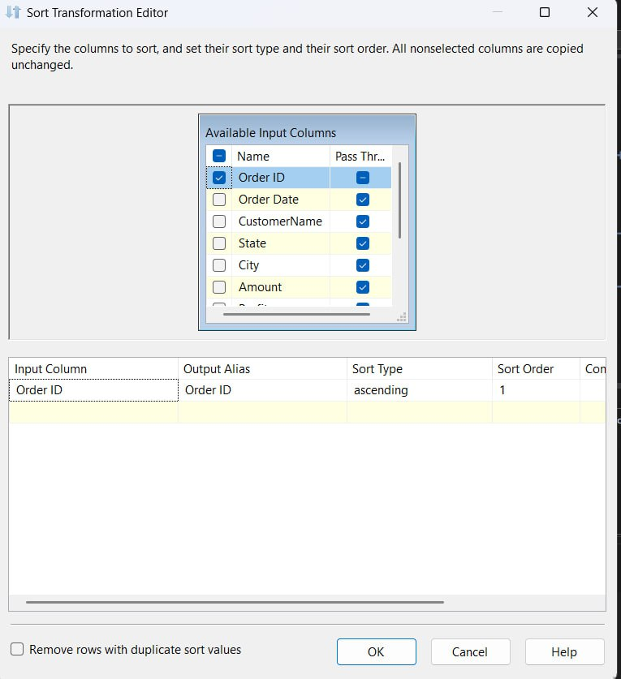

In Dim_ListOfOrders and Dim_OrderDetail, I check the mappings setting

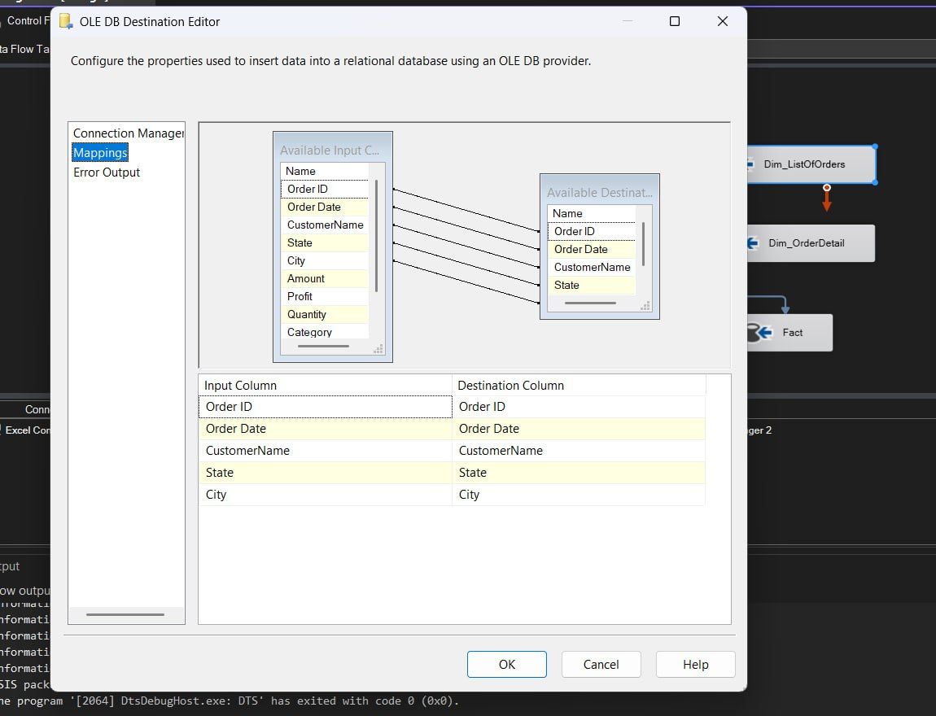

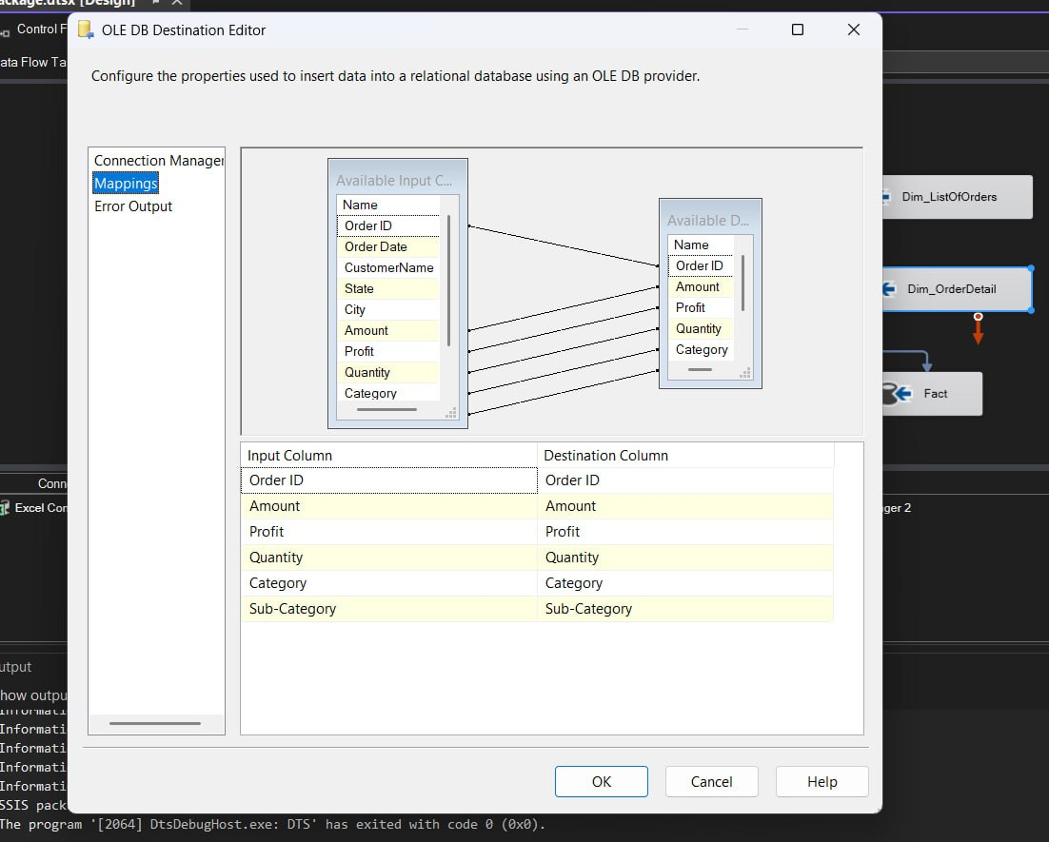

Next, I set up the Control Flow to execute SQL tasks

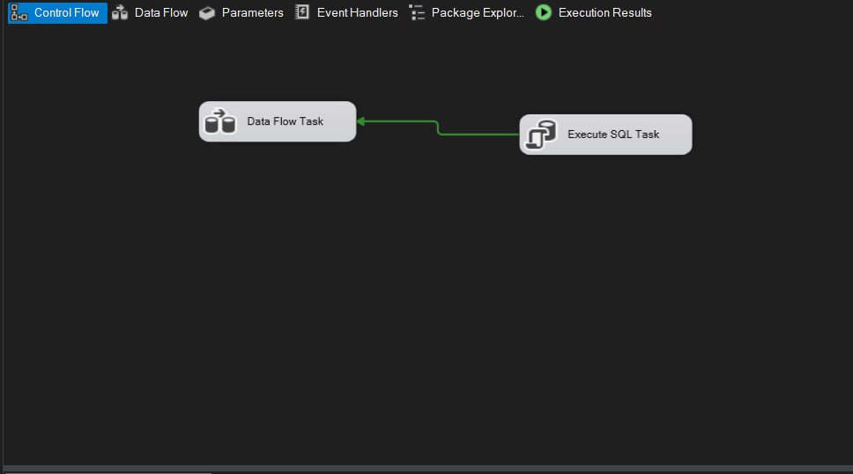

Start the project in Data flow to check if it operates smoothly

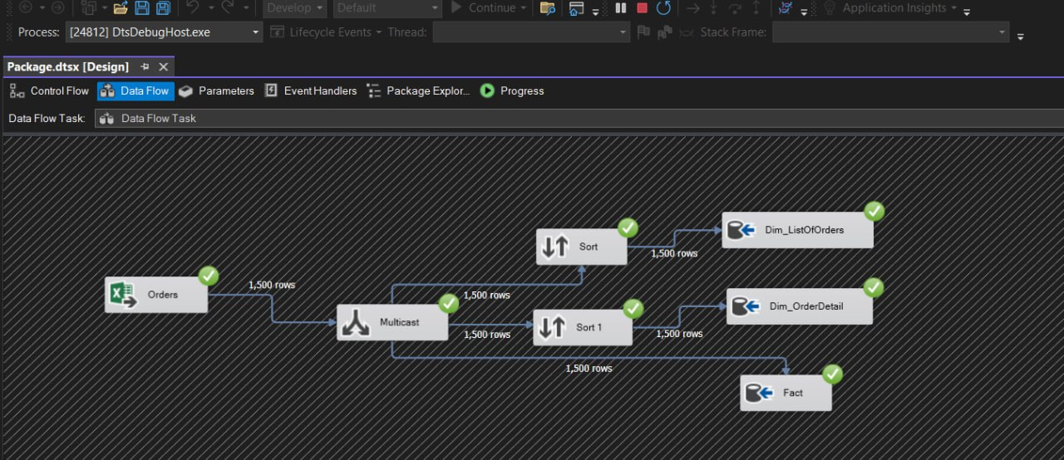

Run SQL query code to collect data from Visual studio for each table

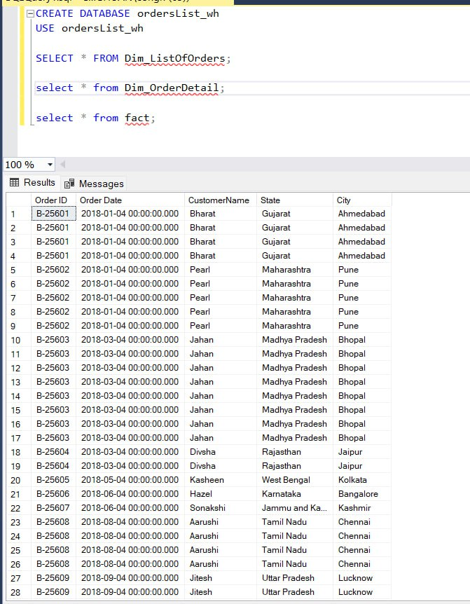

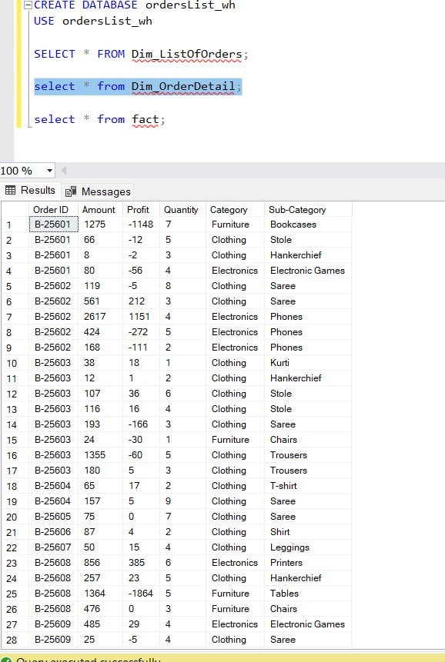

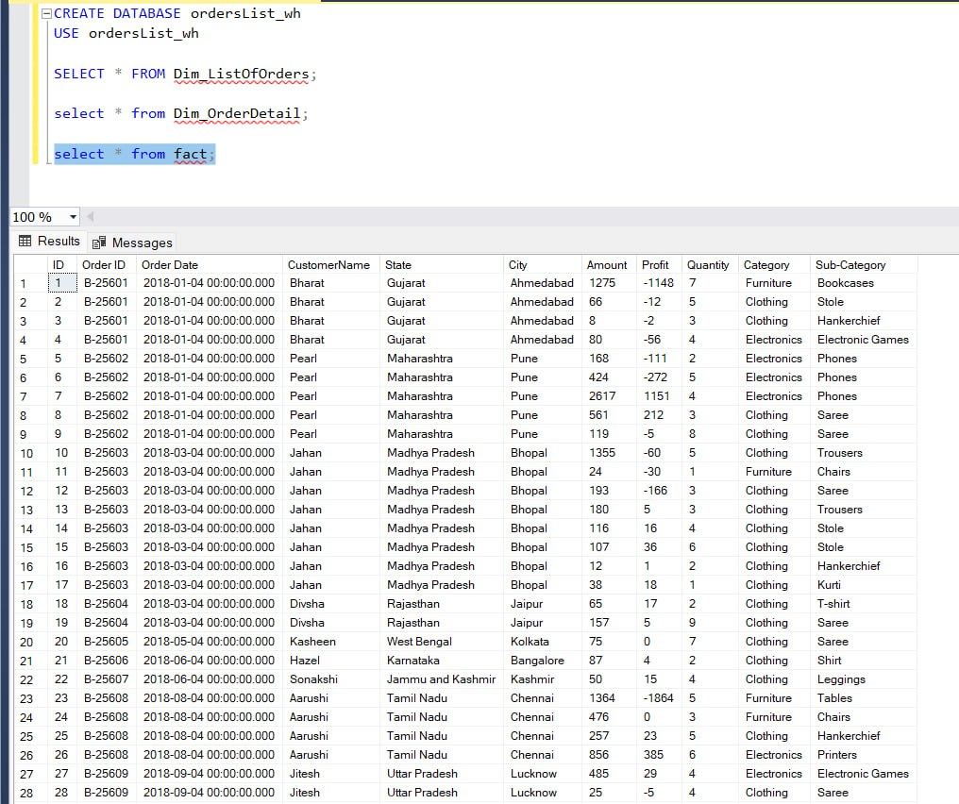

***END***